Metal-organic frameworks, (MOFs) for water sorption for cycling heat transformation processes
Christoph Janiak

Institut für Anorganische Chemie und Strukturchemie, Heinrich-Heine-Universität Düsseldorf, 40204 Düsseldorf, Germany. Email: janiak@hhu.de

Water-stable MOFs with suitable water uptake capacity are gaining attention for reversible cycling water sorption in order to achieve low temperature heat transformation applications in adsorption heat pumps (AHPs), following our first report [1]. AHPs may be alternatives or supplements to conventional compression systems operating with high input of electricity. By using low grade heat as the driving energy, AHPs can significantly help to minimize electricity consumption. AHPs are based on the evaporation and consecutive adsorption of coolant liquids, preferably water (Figure 1a). The process is driven and controlled by the microporosity and hydrophilicity. Yet, the specific temperature boundaries for evaporation, desorption, heat rejection temperature from the adsorbent and the condenser for a desired cycling water sorption application necessitate the tailoring of the adsorbent in terms of hydrophilicity/hydrophobicity for optimized working conditions, which we have addressed here with a mixed-linker concept of MOF-160/CAU-10-H (Figure 1b) [2]. Further, for applications of MOFs one of the biggest current issues is to find effective methods to shape these microcrystalline, powdery materials into manageable forms such as monoliths, pellets or surface coatings with sufficient mechanical and chemical stability, maximal bulk density etc. under preservation of the crucial MOF porosity properties. We have approached this task successfully with MOF@polymer in different binder composites under retention of MOF porosity and hydrophilicity (Figure 1 c, d) [3].
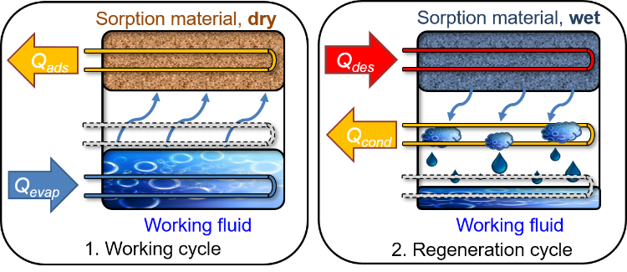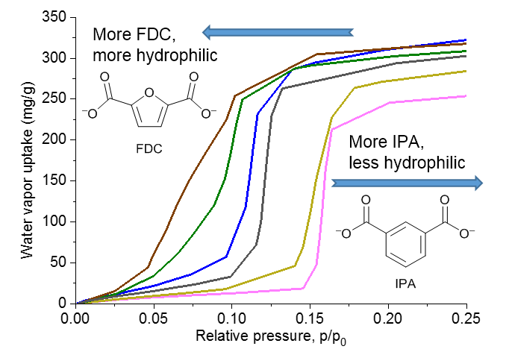
(b)
(a)
(c) (d) 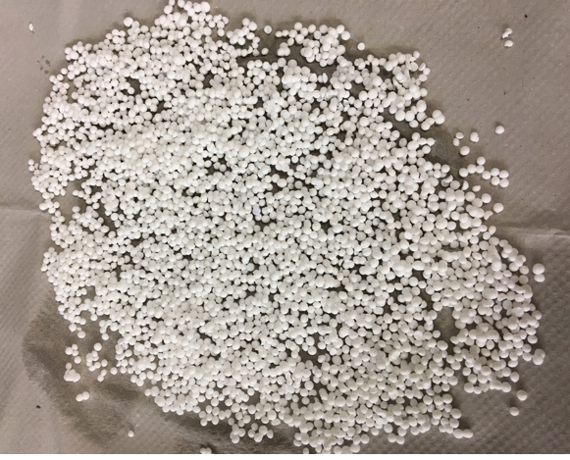
Figure 1. (a) Schematic illustration of the principle of adsorption heat pumps with the useful/needed enthalpies. (b) Hydrophilicity tuning through the transition of a mixed-linker Al-based MOF from MIL-160 to CAU-10-H. (c) Shaping of MOFs with polymers into mechanically stable monoliths and (d) shaping of MOFs into robust 1-2 mm diameter grains under retention of MOF porosity.
[1] S. K. Henninger, H. A. Habib, C. Janiak, MOFs as adsorbents for low temperature heating and cooling applications;
J. Am. Chem. Soc. 2009, 131, 2776-2777. D. M. Steinert, S.-J. Ernst, S. K. Henninger, C. Janiak, Eur. J. Inorg. Chem. 2020, 4502-4515.
[2] C. Schlüsener, M. Xhinovci, S.-J. Ernst, A. Schmitz, N. Tannert, C. Janiak, Chem. Mater. 2019, 31, 4051-4062.
[3] S. Gökpinar, S.-J. Ernst, E. Hastürk, M. Möllers, I. El Aita, R. Wiedey, N. Tannert, S. Nießing, S. Abdpour, A. Schmitz, J. Quodbach, G. Füldner, S. K. Henninger, C. Janiak, Ind. Eng. Chem. Res. 2019, 58, 21493−21503..

